Additional figures and tables
Baseline Demographics | No. of subjects (n=75) | excluded (n=1162)
Baseline Demographics | n (%) | n (%) | p value
Gender
Male | 38 (50.7%) | 581 (53%) | 0.69
Female | 37 (49.3%) | 515 (47%)
Presence of siblings | 46 (61.3%) | 589 (53.8%) | 0.21
Mode of delivery
Caesarean | 25 (33.3%) | 322 (29.4%) | 0.47
Vaginal | 50 (66.7%) | 772 (70.6%)
Gestational age
Term (≥37 weeks) | 72 (96.0%) | 992 (90.7%) | 0.12
Preterm | 3 (4.0%) | 102 (9.3%)
Ethnicity
Chinese | 42 (56%) | 648 (55.8%) | 0.89
Malay | 21 (28%) | 303 (26.1%)
Indian | 12 (16%) | 211 (18.2%)
Household monthly income
0-$999 | 2 (2.8%) | 27 (23.8%) | 0.70
$1000-$1999 | 9 (12.7%) | 143 (12.3%)
$2000-$3999 | 25 (35.2%) | 325 (28%)
$4000-$5999 | 13 (18.3%) | 277 (23.8%)
>$6000 | 22 (31%) | 309 (26.6%)
Maternal Tertiary Education | 46 (61.3%) | 668 (58.4%) | 0.62
Antibiotics during pregnancy and/or labour | 35 (46.7%) | 466 (45.2%) | 0.49
Postnatal antibiotics within first 12 months | 16 (21.3%) | 387 (47.4%) | <0.001
Childcare attendance in first year | 7 (14%) | 69 (15.5%) | 0.78
Pet ownership at 12months | 3 (6%) | 51 (10.2%) | 0.34
Smoking exposure in first year | 1 (1.3%) | 43 (5%) | 0.16
Maternal history of atopy | 18 (24%) | 191 (23.2%) | 0.77
Paternal history of atopy | 20 (26.7%) | 180 (21.8%) | 0.27
Eczema up to 18 months | 35 (46.7%) | 148 (12.7%) | <0.001
Rhinitis up to 18 months | 21 (28.4%) | 411 (53.9%) | <0.001
Wheeze with nebulizer use up to 18 months | 5 (7%) | 101 (15.1%) | 0.06
Allergen sensitization at 18 months | 15 (23.1%) | 99 (12.6%) | 0.02
Hospitalisation in the first year | 5 (6.7%) | 178 (22.7%) | 0.001
Illness diagnosed in the first year | 38 (50.7%) | 523 (63.5%) | 0.027

Additional Table 1.Comparison of demographic variables between subjects included and excluded from study
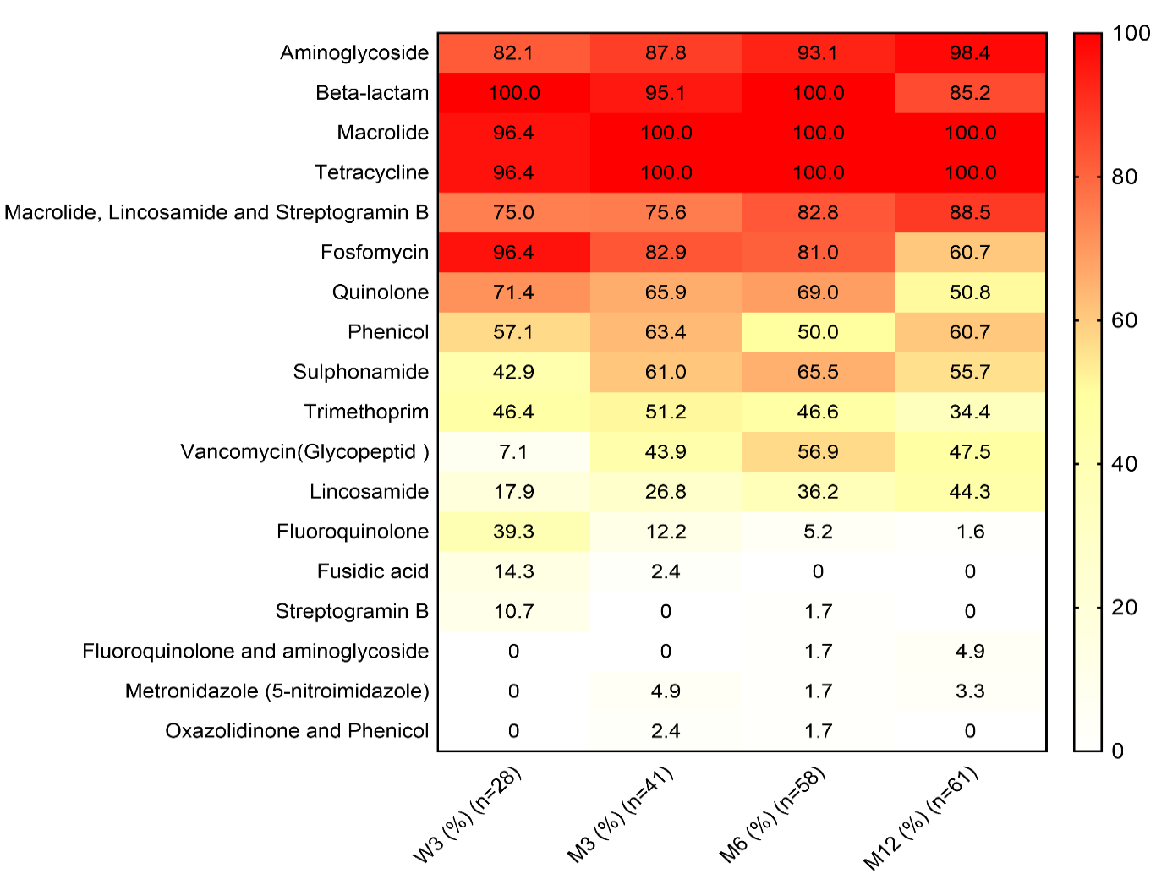
Additional Figure 1. Antibiotic resistance genotypes over time. The percentage of subjects with the antibiotic resistance genotype are presented over time.

Class | Drug Class | Type of antibiotics received during pregnancy | No. of subjects
Beta-lactam | Beta-lactam | Cefalexin capsule | 3
Beta-lactam | Penicillin | Amoxicillin capsule | 6
Beta-lactam | Penicillin | Amoxicillin capsule, Cloxacillin capsule | 1
Macrolide, Beta-lactam | Macrolide, Penicillin | Erythromycin ESS, Amoxicillin | 3
Macrolide | Macrolide | Azithromycin | 1
Additional Table 2. Maternal antibiotic exposures during pregnancy.

Class | Drug Class | Type of antibiotics during labour | No of subjects
Lincosamide | Lincosamide | Clindamycin | 1
Beta-lactam | Penicillin | Penicillin G | 13
Beta-lactam | Penicillin | Ampicillin/Amoxicillin | 7
Beta-lactam | Penicillin, Cephalosporin | Penicillin G, Cefazolin | 1
Beta-lactam | Cephalosporin | Cefazolin | 4
Beta-lactam | Cephalosporin | Rocephine | 1

Additional Table 3. Maternal antibiotic exposure during labour.

